Internet of Things (IOT)

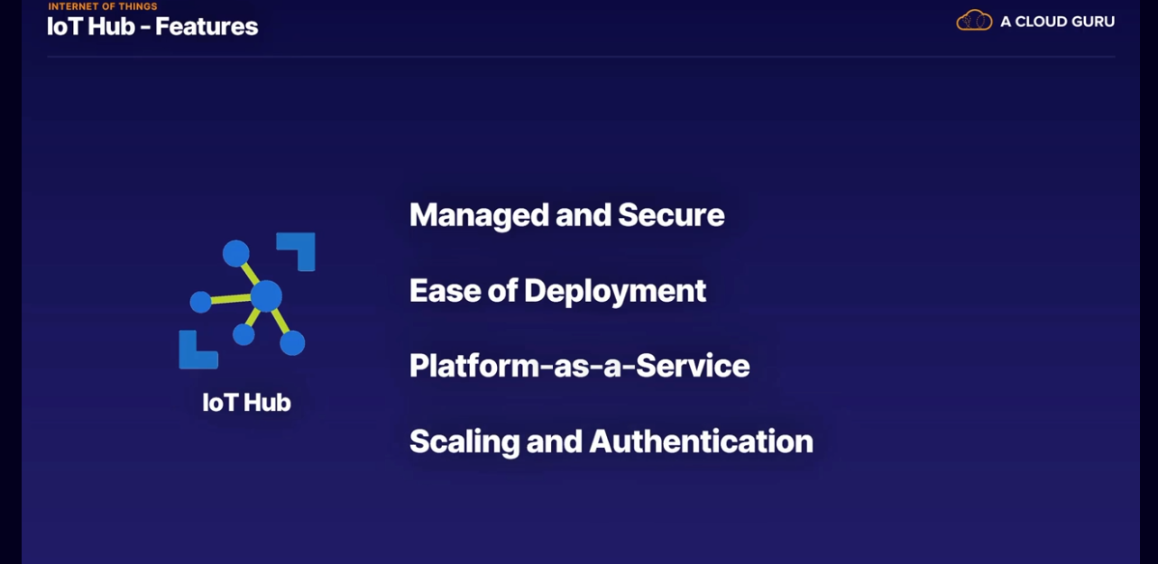

New devices can be deployed

The Internet of Things is a system of interrelated computing devices, mechanical and digital machines, objects, animals, or people that are provided with unique identifiers and the ability to transfer data over a network without requiring human-to-human or human-to-computer interaction.

IoT Hub: it is a hub to collate data feeds from all your things. It is what is called a backend, meaning the system they receive the data and manages it. It can receive data from millions and according to Microsoft, even billions of devices. These devices are meant to be autonomous

IoT Hub is Platform-as-a-service

IoT Central: IoT Central helps simplify the setup of your IoT solution and can be a really fast way to get your IoT solution running. You don't have to write any code to connect all your things. IoT Central receives the feeds from your devices and provides you with dashboards, metrics, and rules to manage it all.

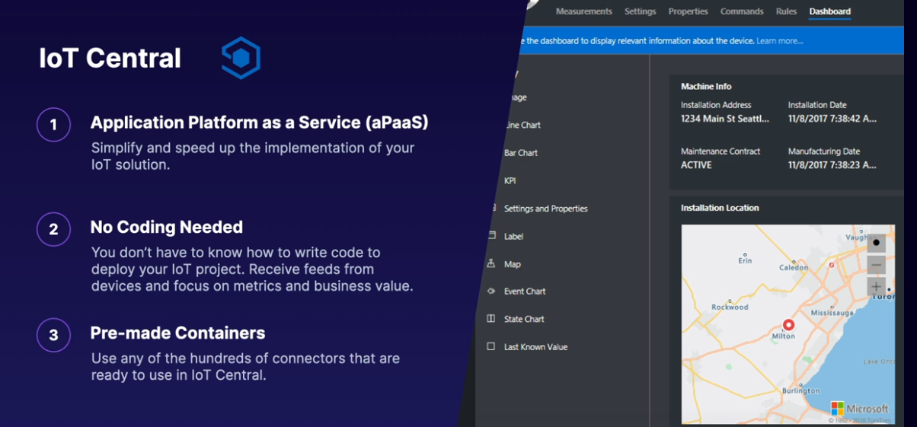

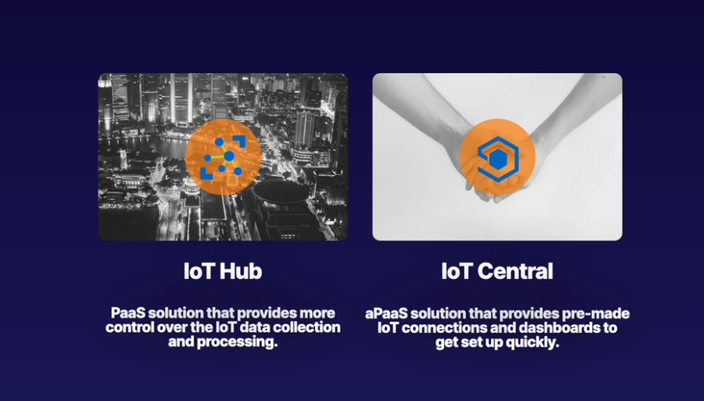

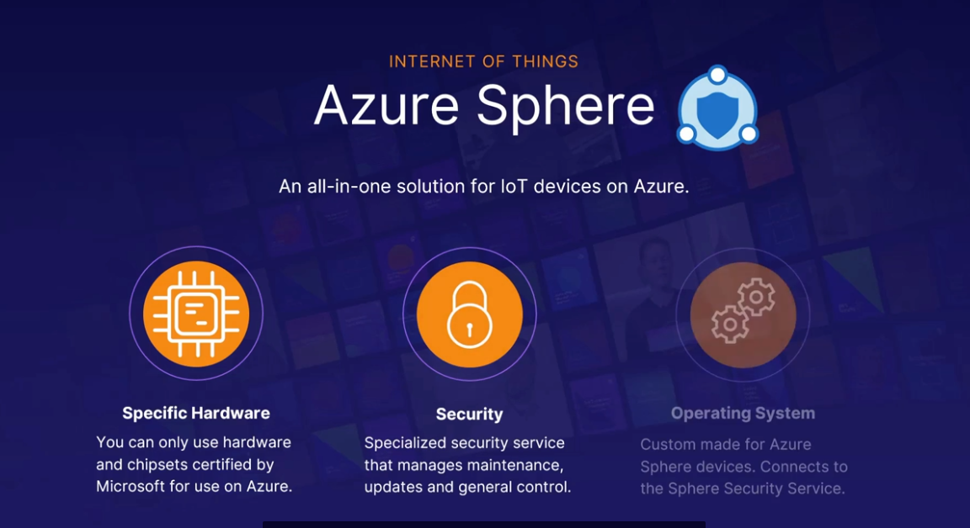

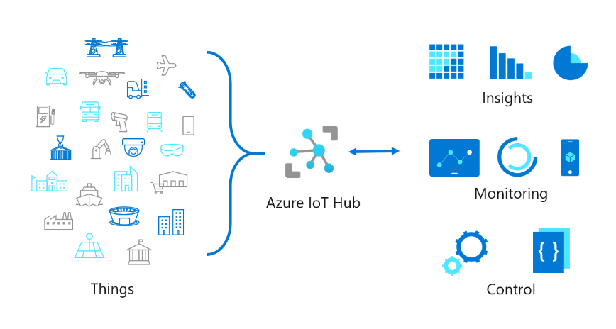

Big Data

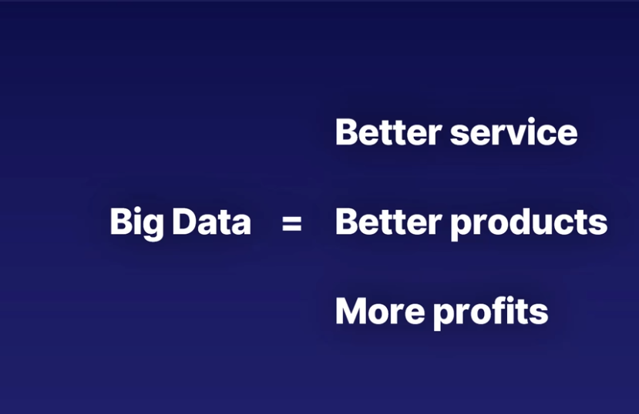

Business values

Think data from millions of devices in an Internet of Things scenario, for example. Big data keeps changing, though. As we can process more and more data, the definition of what is big data moves as well.

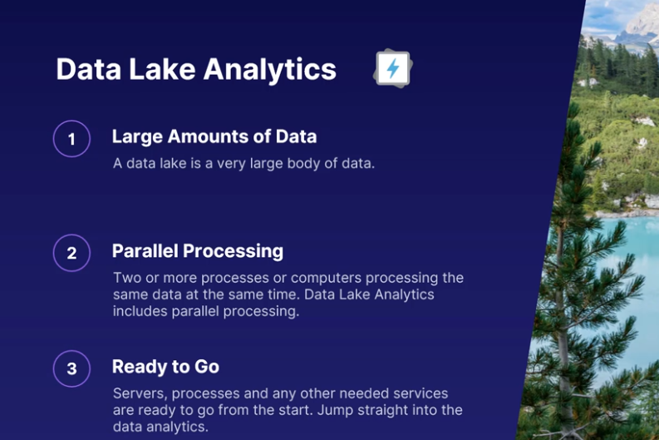

Azure Data Lake Analytics (ADLA) is a cloud-based data processing architecture that helps organizations manage big data workloads. It's an on-demand analytics platform that allows users to develop and run programs to transform and process data in parallel. Users can write queries to transform data and extract insights instead of deploying, configuring, and tuning hardware.

Azure HDInsight is an analytics service that allows users to analyze and process large volumes of data quickly. Azure Data Lake Analytics is a storage service that makes it easy for data scientists, developers, and analysts to store data of any shape, size, and speed.

HDInsight is a cloud-based service that provides a software framework for managing, analysing, and reporting on big data. It supports various data ingestion methods, including Azure Data Lake Storage, Azure Blob Storage, Azure Event Hubs, Azure Stream Analytics, and Apache Kafka. HDInsight also gives users full control over the configuration of their clusters and the software installed on them.

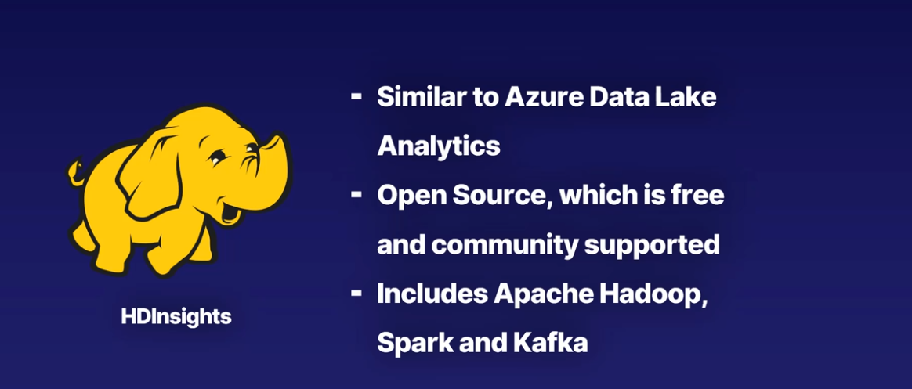

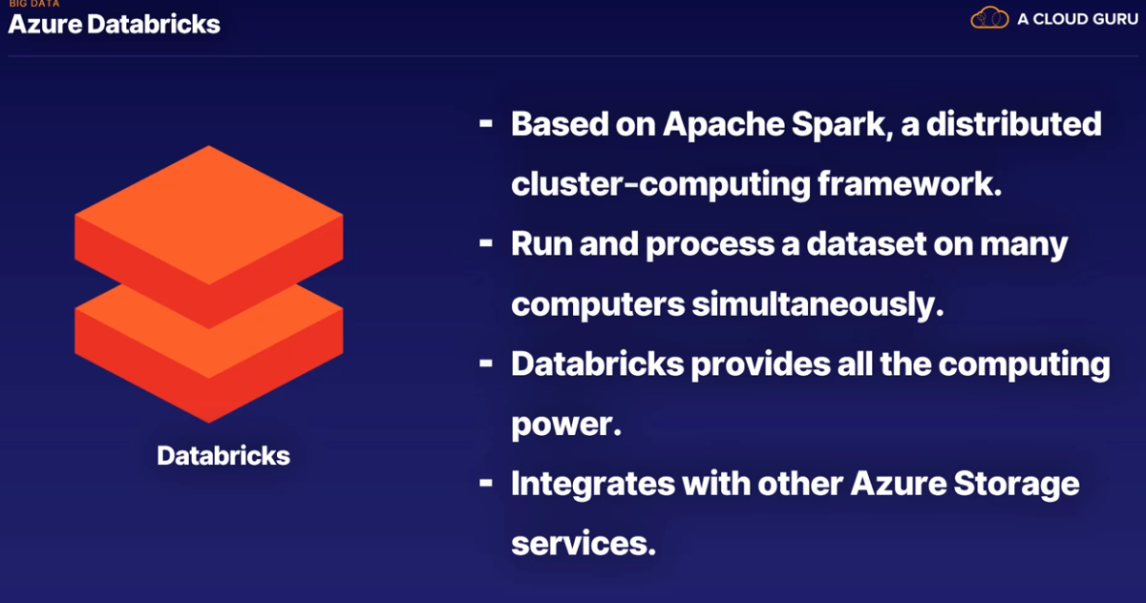

Cloud service

No need to buy lots off computers and no need to maintain them.

Even data lake and Hadoop storage services

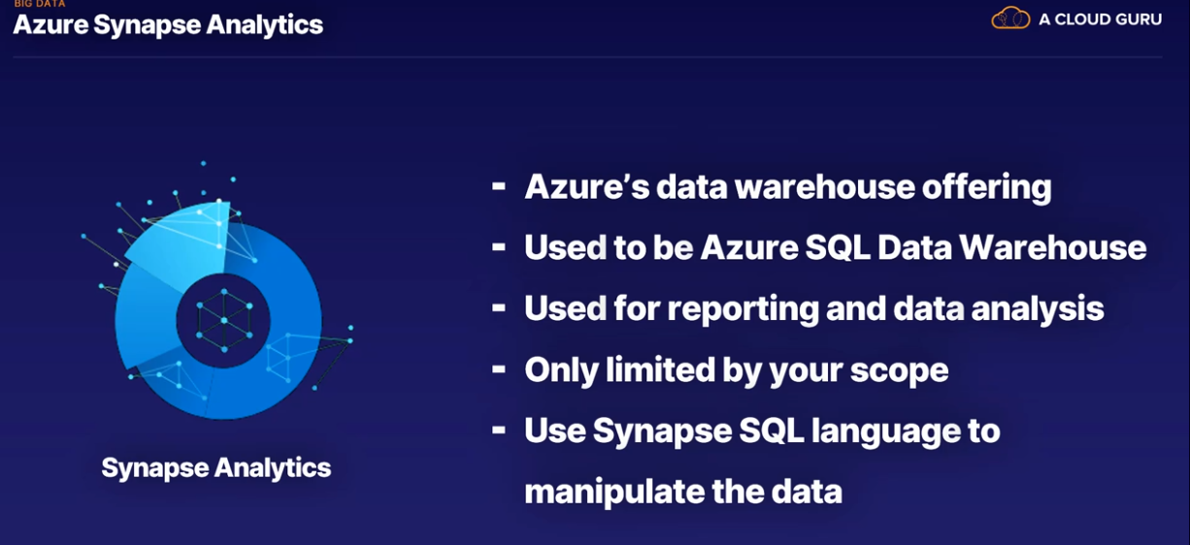

Data warehouse solution for azure

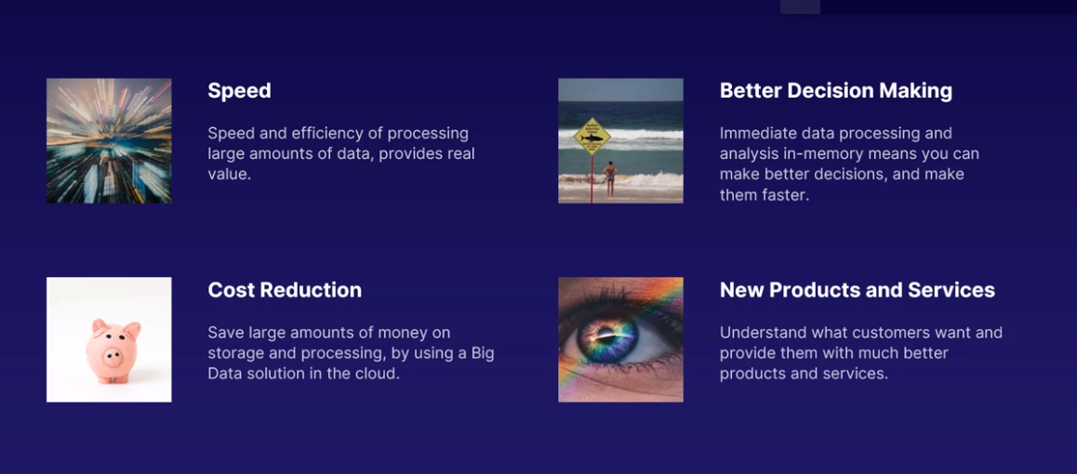

Machine Learning

AI is the capability of machines to imitate intelligent human behavior. Through AI, machines can analyze images, comprehend speech, interact in natural ways, and make predictions using data.

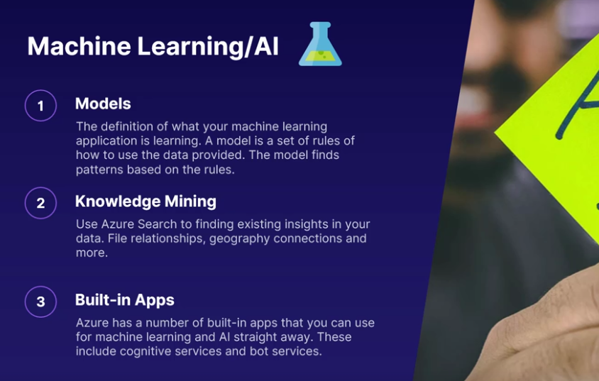

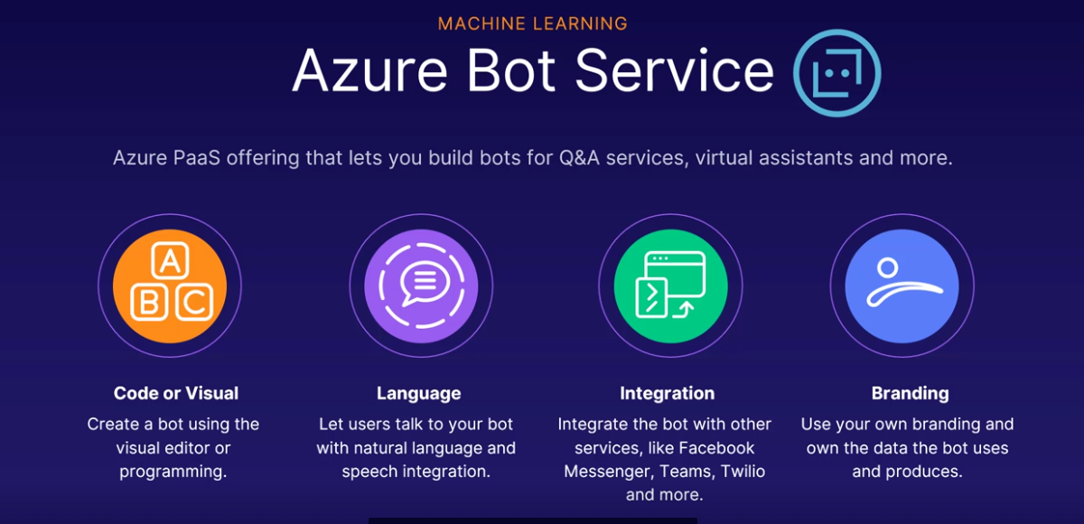

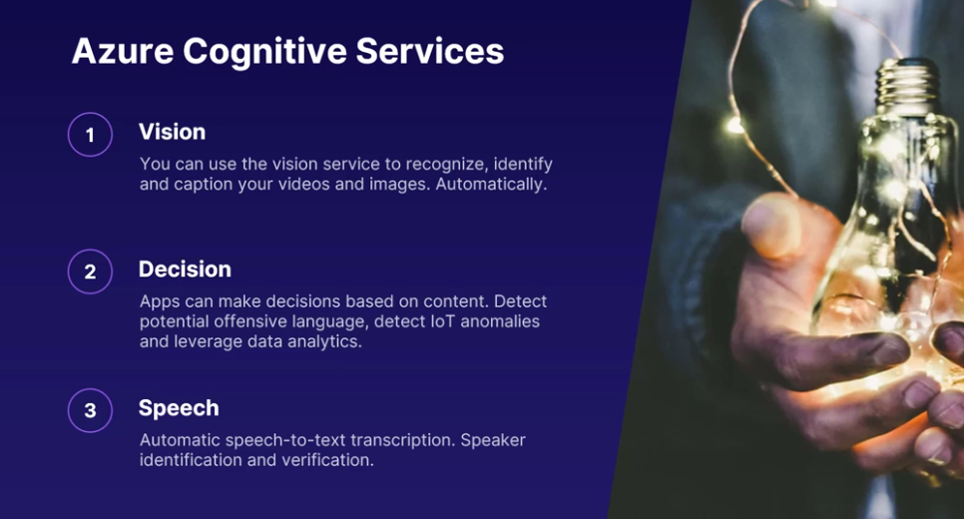

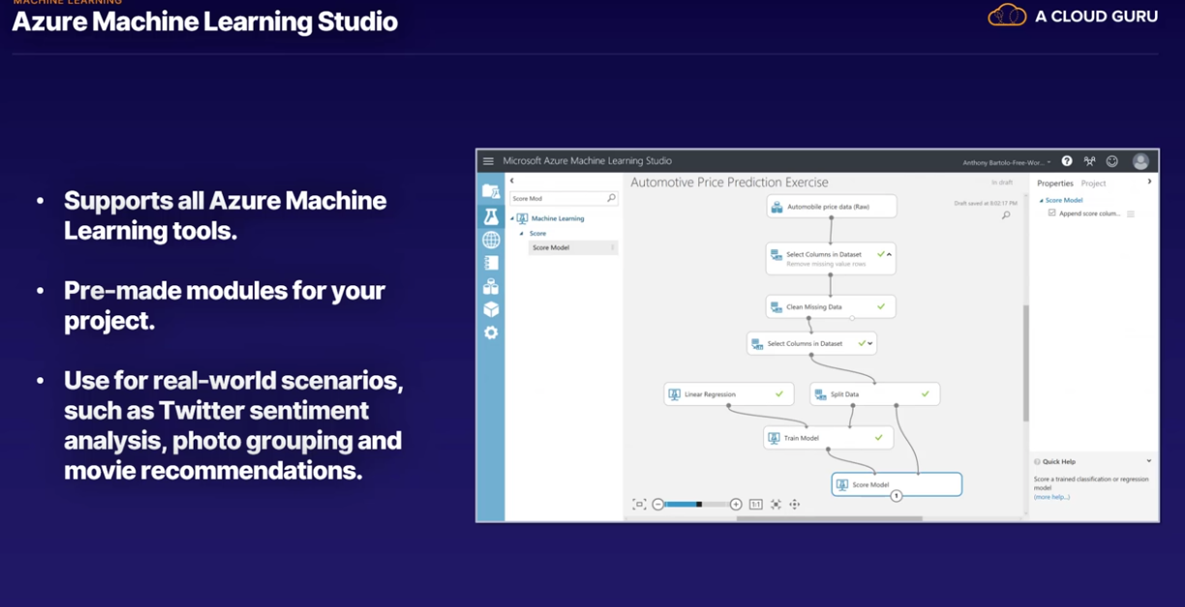

Azure machine learning studio:

This is a visual tool that can help you manage all of your machine learning needs. It supports all the various programming languages, data sets, models, projects, and services that are available in Azure for machine learning.

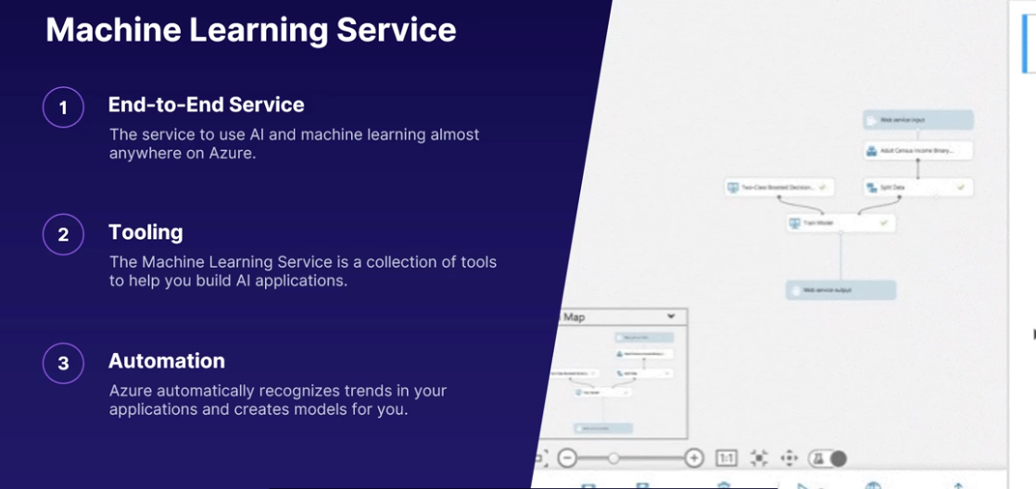

serverless is, of course, not serverless. Serverless refers to the fact that you aren't managing any servers yourself, at all.

Server less

Your applications are running on someone else's server. Serverless is an extreme version of Platform as Service, or PaaS. It means Azure will manage all the services you use.

What is serverless ??

Three server less products-

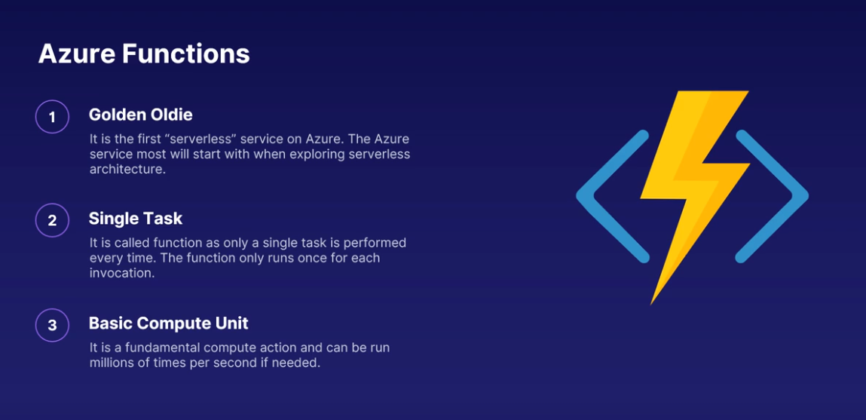

Original server less product on azure

Azure Functions provide all the resources needed to run applications, so developers don't need to worry about deploying and maintaining servers. Azure Functions can also be programmed to build code automatically on demand. Saves cost.

* Examples : Sending emails
* Starting backups
* Processing orders
* Scheduling tasks
* Sending notifications
* Processing IoT data
* Processing data streams
* Running background backup tasks
* Computing backend calculations
* Lightweight Web APIs

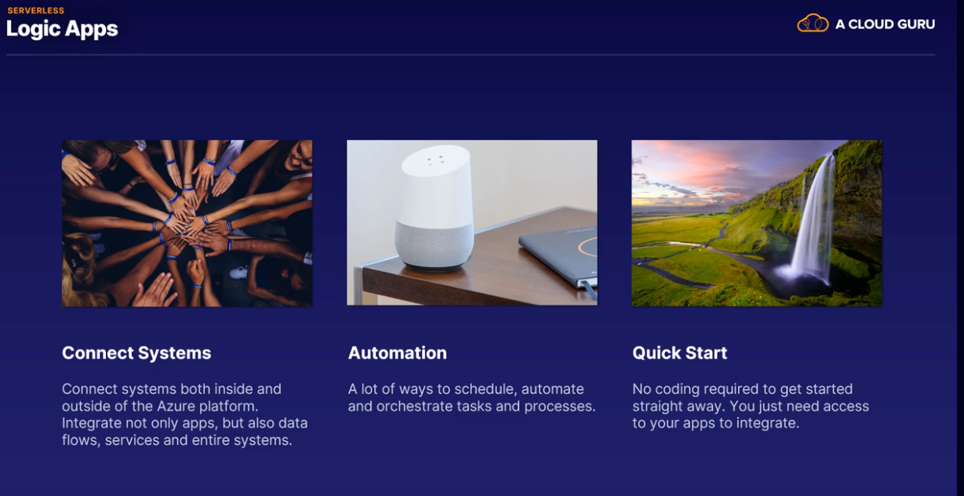

You can connect a ton of different applications either manually or using templates. There's no code needed, no servers to set up, and you can get started very quickly.

Event Grid-

It is a routing service for connected applications, making sure events are sent and received fast and accurately. It's a serverless service because you don't manage any infrastructure.

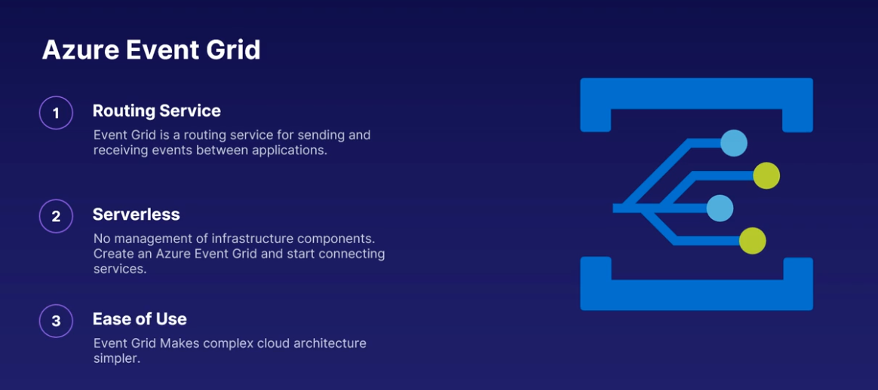

Serverless solutions on Azure are a major reason to use the cloud platform. Removing the need to manage servers and infrastructure and simply focus on the immediate task of solving a business problem saves time, money, and gets you to market quicker.

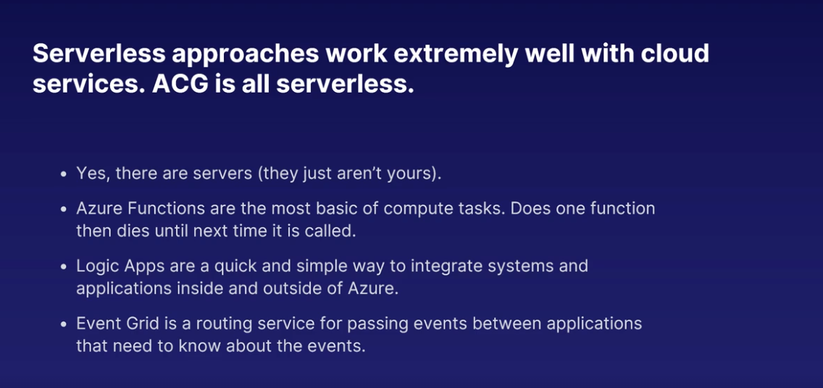

Azure Devops

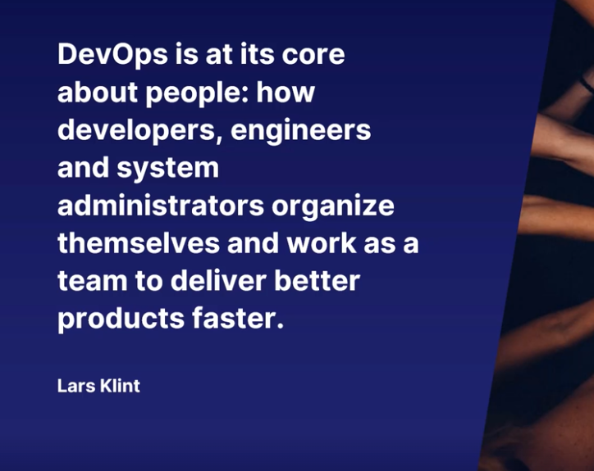

Tools:

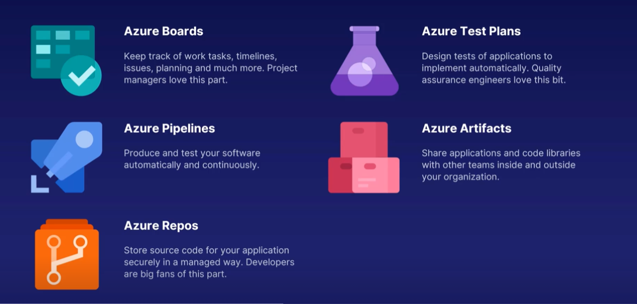

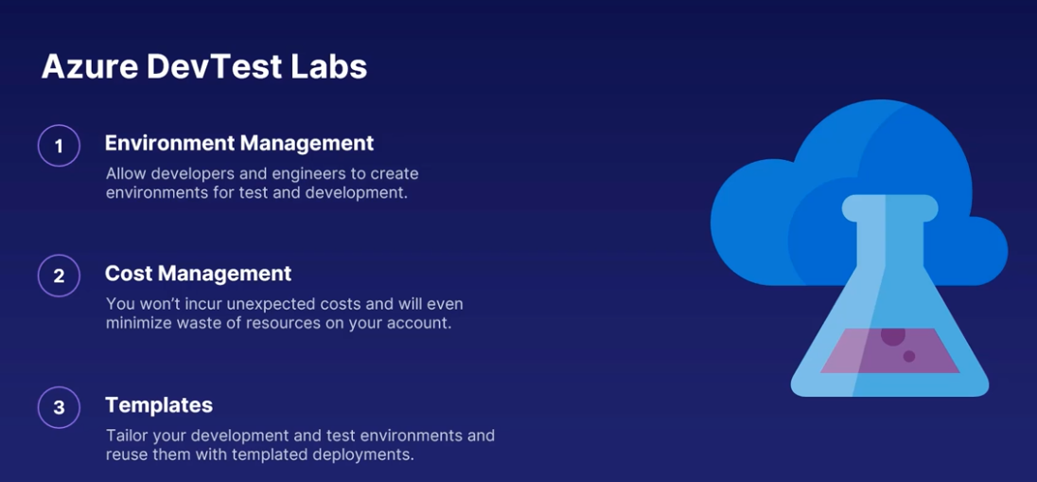

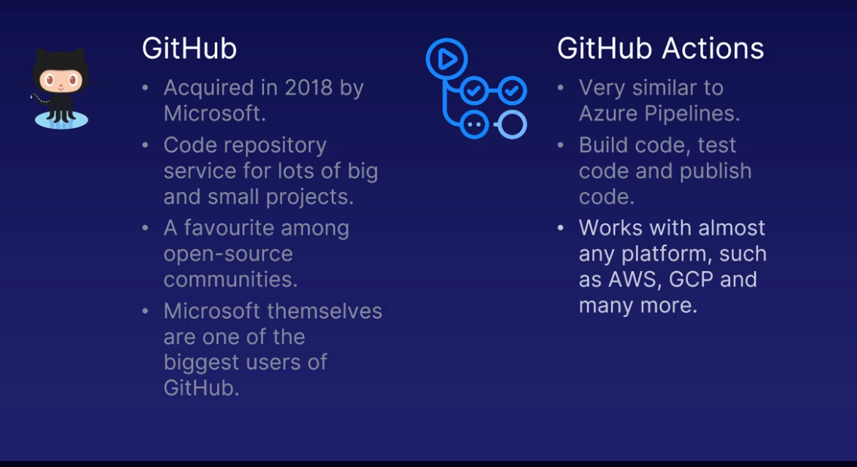

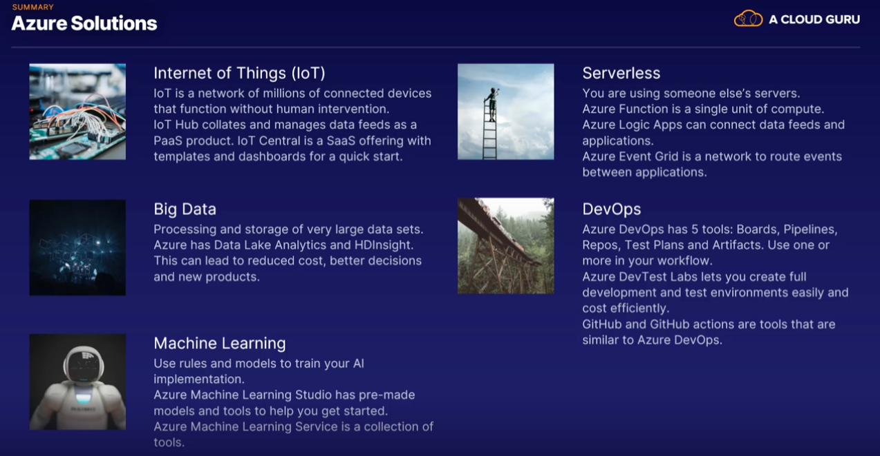

1.Which are Internet of Things services on Azure?

* IoT Central
* IoT Hub.
* IoT Services
* IoT App Services
* IoT Virtual Box
* IoT Management Studio

2. When would you use Azure Logic Apps to solve a problem?

* For fundamental compute actions that can be run millions of times per second if needed
* To perform single tasks that run once every time they are invoked
* When you have to use more than one Azure subscription
* To connect systems both inside and outside of the Azure platform
* To schedule, automate, and orchestrate tasks and processes

Good work!

Logic Apps connect systems both inside and outside of the Azure platform, integrating not only apps but also data flows, services, and entire systems.

There are a lot of ways to schedule, automate, and orchestrate tasks and processes using Logic Apps.

3. What is the best definition of Azure DevOps?

* A platform to manage Azure resources meant for development, such as App Services, Azure Functions, and Visual Studio Online.
* A suite of five different tools to create more robust software, faster
* A specific section of the Azure portal where you can manage operational parts of your infrastructure
* A way to write better code and find bugs faster

Good work!

Azure DevOps is a set of modern tools to create more robust software, faster. It is used by both operational people and developers to manage the entire lifecycle of software products. It has its own separate web portal, but it is fully integrated into Azure. It isn't only meant for development services on Azure but all services to which you can deploy code and infrastructure.

4. What are some of the likely outcomes from using Azure Data Lake Analytics to analyze big data?

* A cost reduction on data storage
* More secure access to company infrastructure
* Creating products better aligned to customer needs
* Cheaper and more accessible cloud computing products
* Better decision-making from immediate analysis
* A decoupling of business decisions from the development of new products

Analyzing Big Data can often lead to more precise decision-making for a business, a cost reduction on the storage of the data using a service like Azure Data Lake, and better products that take customer feedback and behavior into account.

5.Which of the following are tools in Azure DevOps?

* Azure Deployment
* Azure Operations
* Azure Automation
* Azure Pipelines
* Azure Boards
* Azure Artifacts

6.What is the purpose of "models" in machine learning and artificial intelligence?

* Defining the version of your machine learning application
* The size and capacity of the machine learning service
* The definition of what you want your machine learning implementation to learn
* The framework for integrating other Azure services with your particular machine learning instance

A model is the way you define what you want your machine learning implementation to learn. You give it a model, which is a set of rules, and the application then starts playing this model over and over again with the data you have provided. Over time, usually very fast, the model will find patterns in the data that follow the rules you have provided.